Exercise 8

A)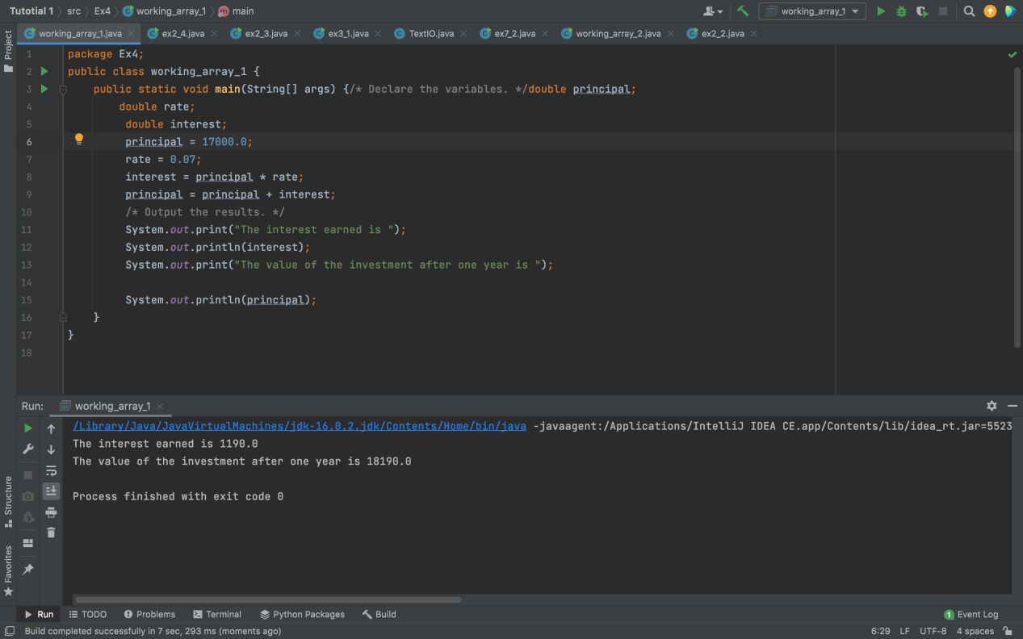

Yes it works because it’s type double

B)

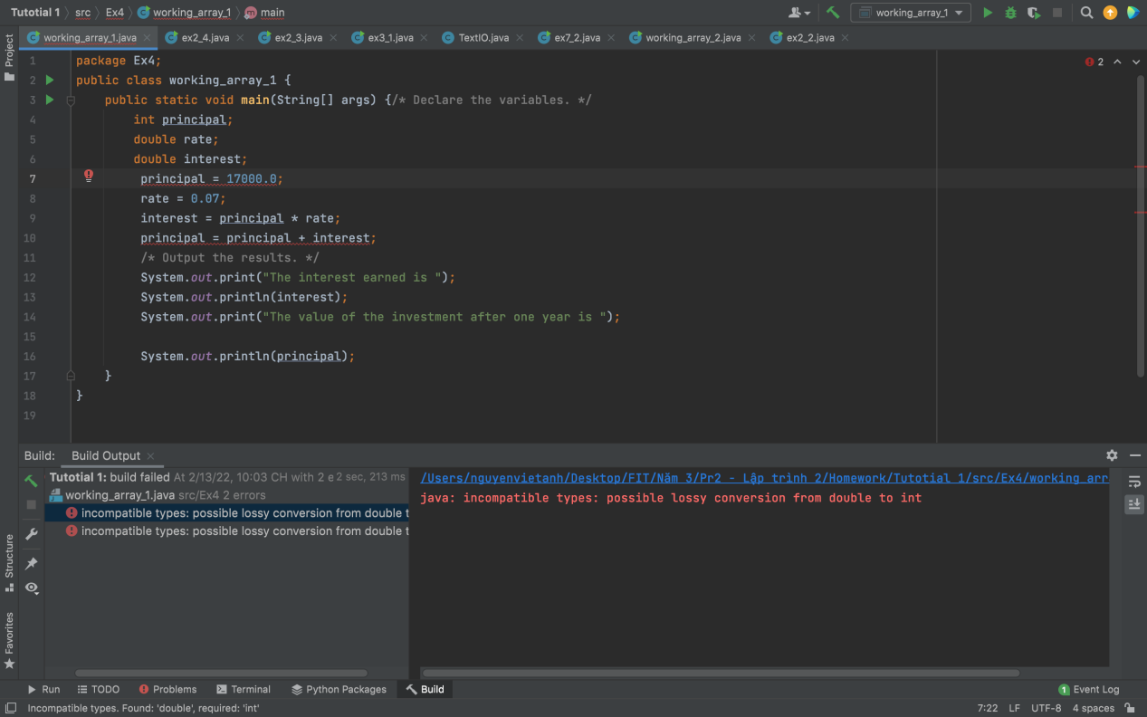

No because it’s different types. We can change the type of interest from double to int

Exercise 10

A)

The statement in line 10 include the array

B)

Yes it does work.

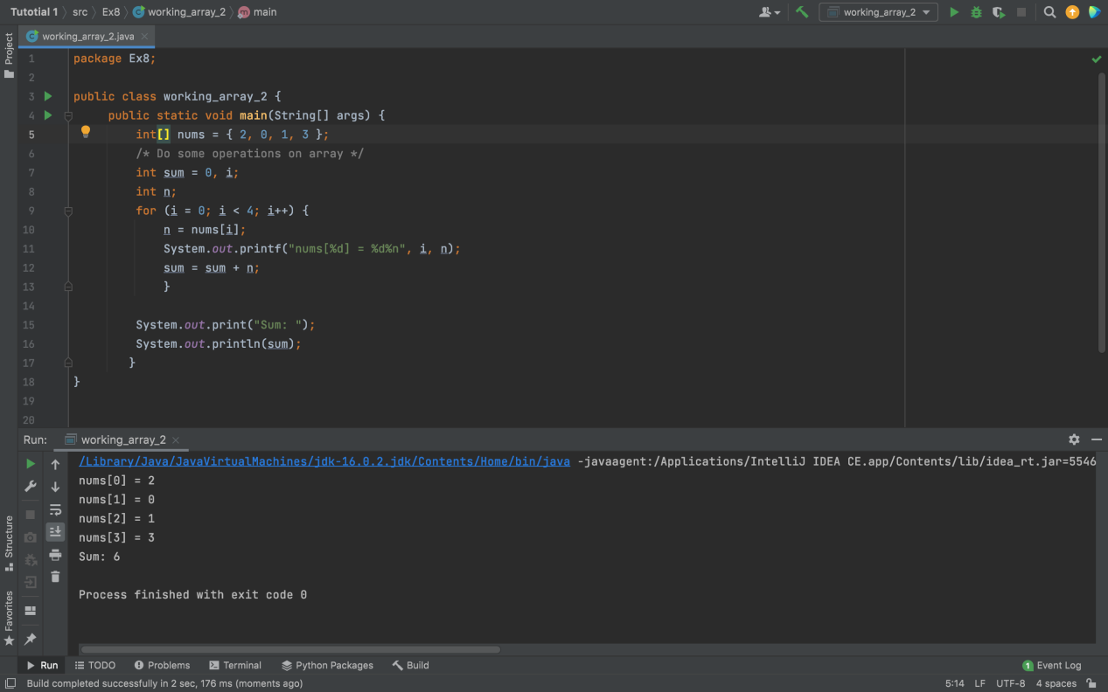

C)

System.out.printf("The String **object** %s is at hash code %h%n", s, s)